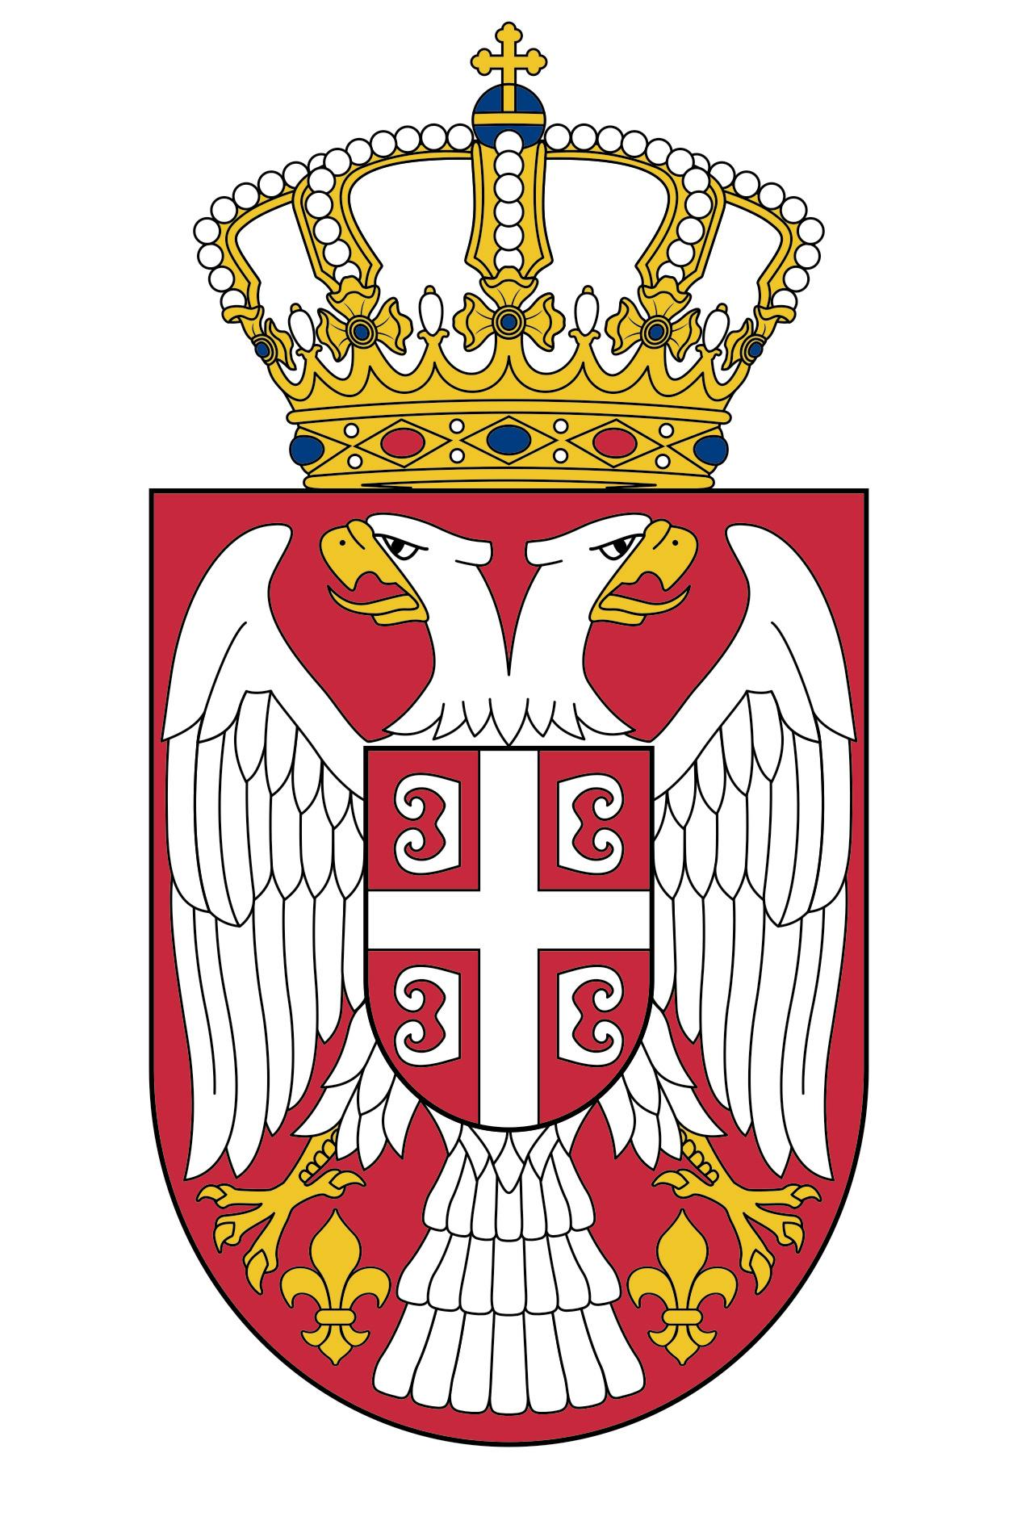
12 Trelawney Street
Woollahra NSW 2025
PO Box 190, Edgecliff NSW 2027
Tel: 02 9362 4638
Fax: 02 9362 4555
e-mail: gkrssid@optusnet.com.au
www.sydney.mfa.gov.rs
CONSULATE GENERAL OF
THE REPUBLIC OF SERBIA
SYDNEY

MARRIAGE CERTIFICATE APPLICATION

Could you please obtain, for my personal purposes, Marriage Certificate with the
information as follows:

Place and Municipality of the Marriage Registration: ______________________

___________

Date of the Marriage Registration: _____

Bridegroom:

Name and Surname: ___________

Date of Birth: ___________

Place and Municipality of Birth: _____

___________

Bride:

Name and Surname: ___________

Date of Birth: ___________

Place and Municipality of Birth: _____

___________

Place of residence in Australia and contact telelepphone number of applicant:

________________________________________________________________

THE APPLICANT

_______________________________
( Signature- given names and surname)

ID card No.______________________

Issued by _______________________

